09 photo interrupter module

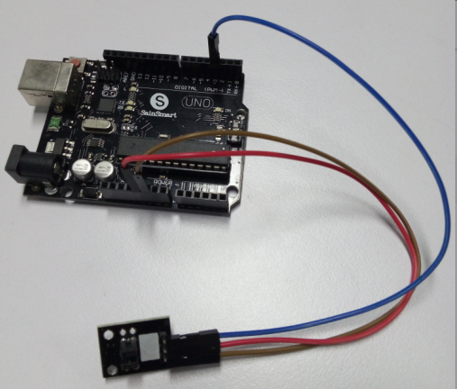

int Led=13;//define LED Interface

int buttonpin=3; // define the photo interrupter sensor interface

int val;//define numeric variables val

void setup()

{

pinMode(Led,OUTPUT);//define LED as output interface

pinMode(buttonpin,INPUT);//define the photo interrupter sensor output interface

}

void loop()

{

val=digitalRead(buttonpin);//digital interface will be assigned a value of 3 to read val

if(val==HIGH)//When the light sensor detects a signal is interrupted, LED flashes

{

digitalWrite(Led,HIGH);

}

else

{

digitalWrite(Led,LOW);

}

}